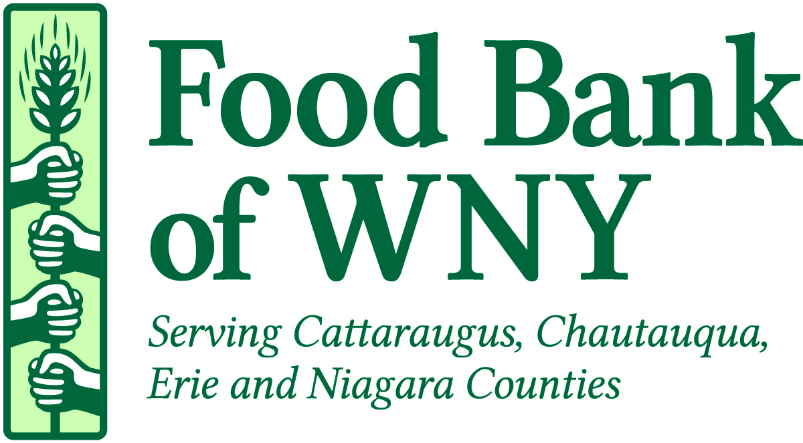

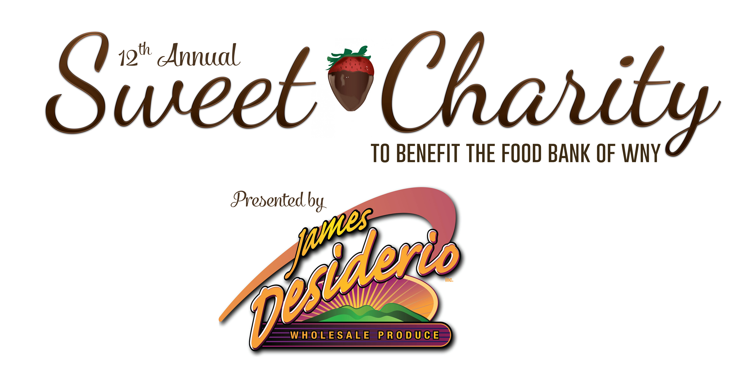

Sweet Charity Restaurant Commitment Form
February 1, 2018, 5:00 PM – 8:30 PM, Adam’s Mark Hotel

We would like to participate at Sweet Charity to benefit the Food Bank of WNY on February 1, 2018.
CONTACT INFORMATION:

Contact Name: ___________________________________________________________________________

Restaurant: ______________________________________________________________________________

Address: ________________________________________________________________________________

City: _________________________ State: ______ Zip: ___________

Telephone ___________________________ Email Address ____________________________________

We will be serving the following three (3) items:

- __________________________________________________________________________________

- __________________________________________________________________________________

- __________________________________________________________________________________

Will you require electrical power? Yes _______ No _______

Please return this form to the Food Bank via email (jmeegan@foodbankwny.org), fax 852-7858 or mail to Jen Meegan Food Bank of WNY, 91 Holt Street, Buffalo, NY 14206. This form is also available online at foodbankwny.org/sweetcharity.

Thank you so much for your support of Sweet Charity!

